Job 1
Branch – Master

Url: https://github.com/anmol2026git/Assign5_repo.git

Shell script:

cd /var/www/html
sudo rm -rf *
cd
cd /mnt/slave1-machine/workspace/jenkinsassign5_job1
sudo cp -r index.html /var/www/html
cd /var/www/html
sudo chmod 644 index.html
sudo service httpd start

Accessing the Website on Node -1
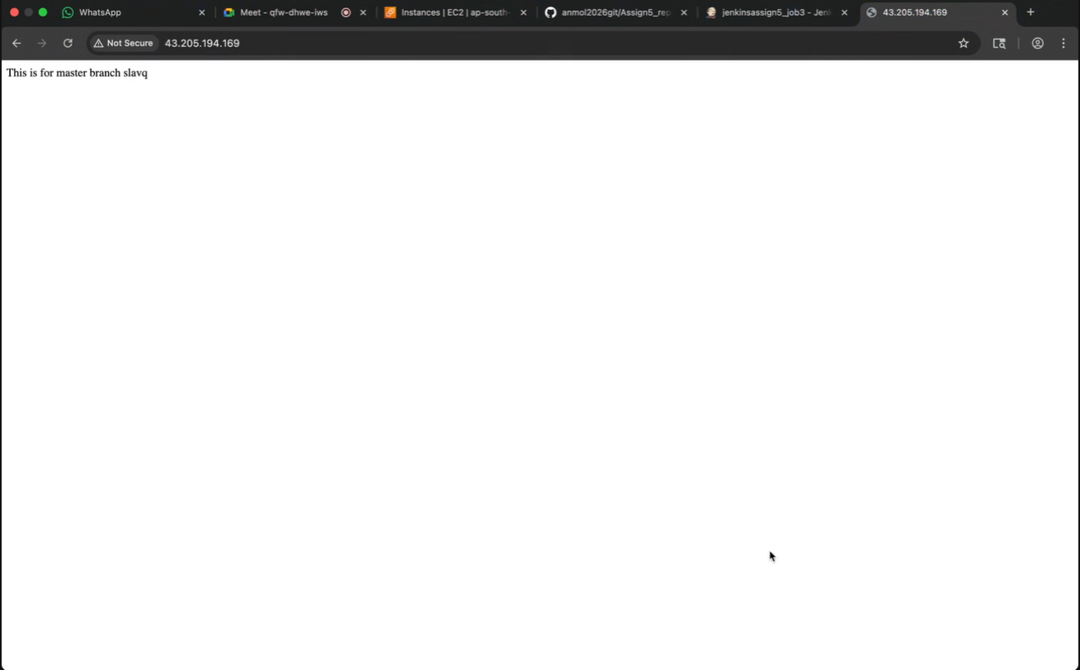

Job2:
Branch – 2026q1
Url: https://github.com/anmol2026git/Assign5_repo.git

Shell script:

cd /var/www/html
sudo rm -rf *
cd
cd /mnt/slave2-machine/workspace/jenkinsassign5_job2
sudo cp -r index.html /var/www/html
cd /var/www/html
sudo chmod 644 index.html
sudo service httpd start

Accessing the Website on Node -2

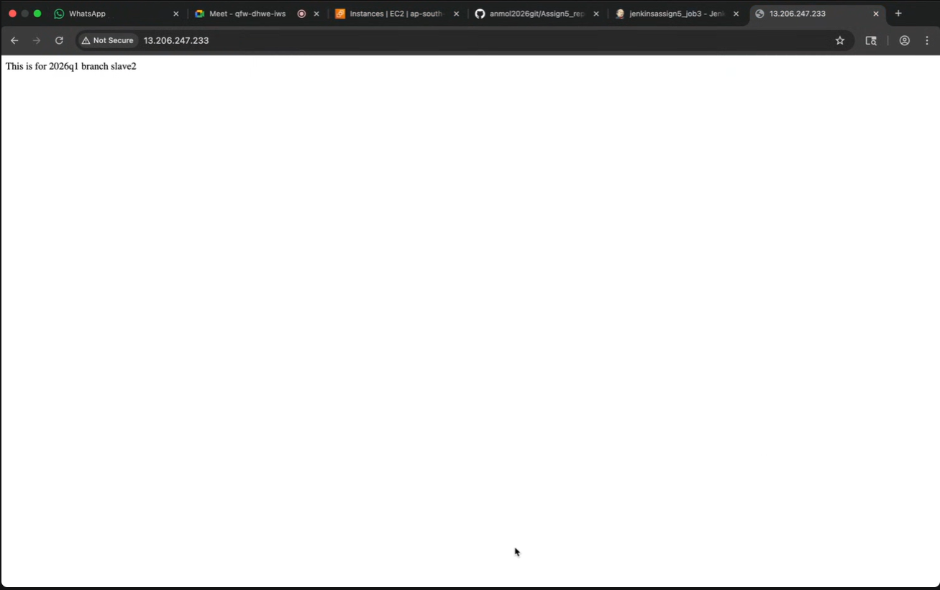

job3:
Branch – 2026q2
Url: https://github.com/anmol2026git/Assign5_repo.git

Shell script:

cd /var/www/html
sudo rm -rf *
cd
cd /mnt/slave3-machine/workspace/jenkinsassign5_job3
sudo cp -r index.html /var/www/html
cd /var/www/html
sudo chmod 644 index.html
sudo service httpd start

Accessing the Website on Node -3

